STEP RIGHT UP
and join us in a
FAMILY READING NIGHT CARNIVAL
On November 29th
From 6-7:30pm!!

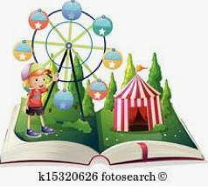

Play games, make a craft and win books.
Can’t wait to see you there!

